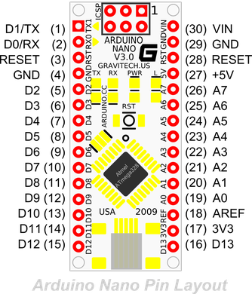Sensor Wiring

White: Pin 1, temperature sensor junction

Orange: Pin 2, pulse-width output

Brown: Pin 3, analog output

Green: Pin 4, rx, ranging start/stop

Blue: Pin 5, tx, serial output

Red: Pin 6, voltage input (2.7 – 5.5 volts)

\*\*or can connect to outside voltage source\*\*

Black: Pin 7, ground

\*\*or can connect to outside voltage source\*\*

RTC Wiring

32K

SQW Pin: Square Wave Output

SCL Pin

SDA Pin

VCC: voltage input (3 – 5 volts)

GND: ground

SD Card Module Wiring



CS: Chip Select Pin

SCK

MOSI

MISO

VCC: voltage input (3 – 5 volts)

GND: ground